Social Studies 7
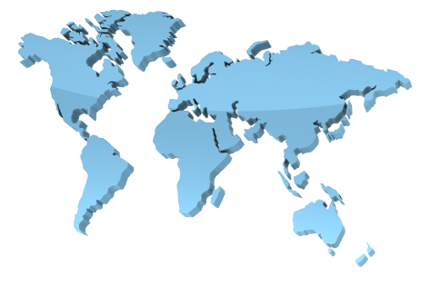
Syllabus

Teacher
Mrs. Tara Merrick
tmerrick@concordia.k12.mo.us

Course Description:
The focus of 7th grade social studies promotes an awareness of the world through the examination of economics, government, and the five themes of geography: location, place human-environment, interaction, movement, and region. As indicated by the State of Missouri grade level expectations, these elements will be used as a lens when examining the Earth's continents and bodies of water. The essential skills and concepts of this course provide the necessary background knowledge for success in this subsequent social studies coursework.

Materials needed:
Pencil/Pen
Loose leaf paper
3 Ring Binder

Interactive Binder:
- Each student is required to keep a binder the entire semester; this includes homework, study guides, vocabulary, projects, notes, and other important information for the class.
- It counts for a grade after each test!
- See notebook organization sheet for more information.

Mrs. Merrick’s Expectations
- BE RESPECTFUL
- BE RESPONSIBLE
- BE YOUR BEST

Consequences for behavior:
- Student will be retaught expectations when behavior is not appropriate.
- 1st offense: Re-direct the inappropriate behavior
- 2nd offense: Re-teach the expectation and provide choices (minor ODR)
- 3rd offense: Major office discipline referral (major ODR)

Grading/Homework guidelines:
- Homework is to be turned in the day it is due at the beginning of class.
- Late homework will not be tolerated!
- Homework is very important to your grade!
- Academic Tutoring:
  - The purpose of an academic tutoring session is to provide time for students who are unwilling to complete their homework. The student either did not complete the assignment in class or did not finish their homework.
  - The academic tutoring session will take place the day the assignment is not turned in afterschool at 3:15. (Example: homework assignment is not turned in on Monday; the academic detention will be served Monday after school.) No exceptions unless student pre-arranges a time to come in before school.
  - While the student is in academic detention they will need to work on the assignment for which they were assigned the detention. When the assignment is complete, their academic detention will be considered served.
  - Students who choose not to stay for the academic tutoring will receive a zero on the assignment and not be able to make it up.

Percentages:

100 A+
93-99 A
90-92 A-

87-89 B+
83-86 B
80-82 B-

77-79 C+
73-76 C
70-72 C-

67-69 D+
63-66 D
60-62 D-
0-59 F

Cheating:

Please see the district policy for cheating in the student handbook. Plagiarism is not acceptable and will not be tolerated. Work that is plagiarized will result in a score of zero for the assignment. Work that is the work of others will also receive a zero.

Projects:
- Projects related to geography units (Australia, Europe, Asia, Africa, North and South America).

Missing Class:
- If a student misses class it is their responsibility to get their missed assignments.
- Students must present the teacher with an excused admit slip to make up their assignments.
- Missing class may result in the student needing to come in before or after school to make up work.
- If work is not made up within 2 days upon returning, you will receive a zero, per board policy

Merrick Pass:
- At the beginning of the semester students will receive a Merrick pass; this pass has 3 available passes to leave the room for the semester.
- Students must have the pass with them to leave the room.
- If a student does not have the pass they may not leave the room unless it is an absolute emergency.
- If a student has passes left at the end of the semester they will receive 10 points extra credit for each pass left.
- You may only use your own Merrick pass, you cannot use someone else’s pass.

Tentative Schedule:
- Unit 1: The World; The Geographer’s World, Physical & Human Geography
- Unit 2: North America; U.S. East & West of the Mississippi River & Canada
- Unit 3: South America; Brazil, Tropical North, Andes and Midlatitude Countries
- Unit 4: Europe; Western Europe, North & Southern Europe, Eastern Europe & Western Russia
- Unit 5: Asia; East Asia, Southeast Asia, South Asia, Central Asia, the Caucasus, and Siberian Russia, Southwest Asia
- Unit 6: Africa; North Africa, East Africa, Central Africa, West Africa, Southern Africa
- Unit 7: Australia & New Zealand, Oceania, Antarctica

I have read and understand the expectations of this class. /20pts

Parent signature: Date:

Print Parent Name:

Parent email:

Parent phone #:

Student signature: Date:

